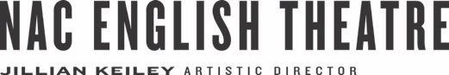
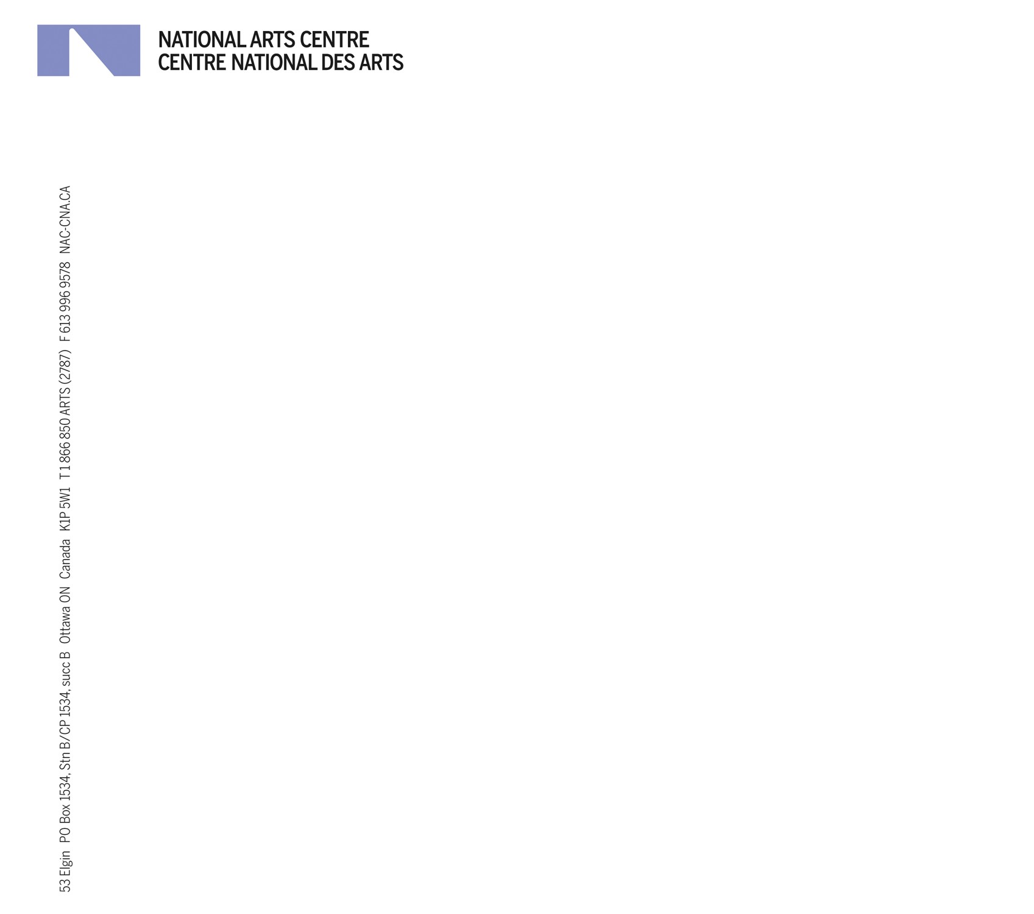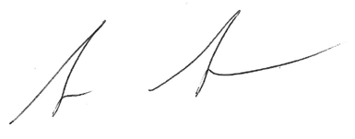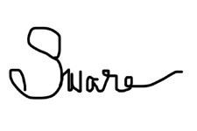

Dear Friends,

We invite you to join us for the two-year culmination of NAC English Theatre’s Deaf, disability and Mad Arts Cycle, called The Republic of Inclusion, June 27-29, 2017 in Ottawa, at the Shenkman Arts Centre.

Last year, we initiated a collaboration with The Stratford Festival, UBC department of Theatre and Film, and Playwrights’ Workshop Montreal wherein we brought together Artists and Leaders from the Deaf, disability and Mad arts communities from across Canada and beyond. These Artists and Leaders offered context and direction in creating this year’s projects: The Study and The Republic of Inclusion.

From June 19 -26, theatre creators, students and scholars will gather in Ottawa to immerse themselves in The Study. Together participants will explore and share aspects of a compendium of Deaf, disabled and Mad works. The Cycle will culminate in The Republic of Inclusion, a three-day immersive event beginning on the evening of June 27, and ending mid day on June 29.

On behalf of all of us in English Theatre and our partners, The Canada Council for the Arts, British Council, The Stratford Festival, Tangled Art + Disability and many others, we invite you to join us at The Republic of Inclusion. We welcome you to an accessible environment designed to celebrate the work of artists who are changing the shape of Canadian theatre, and impacting the processes used for its creation.

If you have any questions, wish to register, or want more information please don't hesitate to contact NAC English Theatre Producing Coordinator Clayton Baraniuk (clayton.baraniuk@nac- cna.ca, tel# 613 947 7000 x386; 1 866 850 2787 x386).

We look forward to seeing you there!

Sarah Garton Stanley Syrus Marcus Ware
Co-Curator – The Cycle Co-Curator – The Cycle
Associate Artistic Director Artist & Facilitator/Designer, The Banff Centre
English Theatre, National Arts Centre Disability Arts Scholar & PhD Candidate, York University
sarah.stanley@nac-cna.ca syrusmarcusware@gmail.com
The Republic of Inclusion

June 27 – 29, 2017
Ottawa, ON

Information

Overview of The Cycle

Since 2006, NAC English Theatre has placed resources into theatre research and development. Starting in 2013 a new project called The Cycle was launched. This project was created by Sarah Garton Stanley in response to Artistic Director Jillian Keiley’s desire to focus on live performance areas impacting our contemporary sense of society.

The Cycle is a two-year project divided into three segments, beginning with The Summit, which provides an opportunity reflect upon and prepare for a more in depth gathering in the second year.
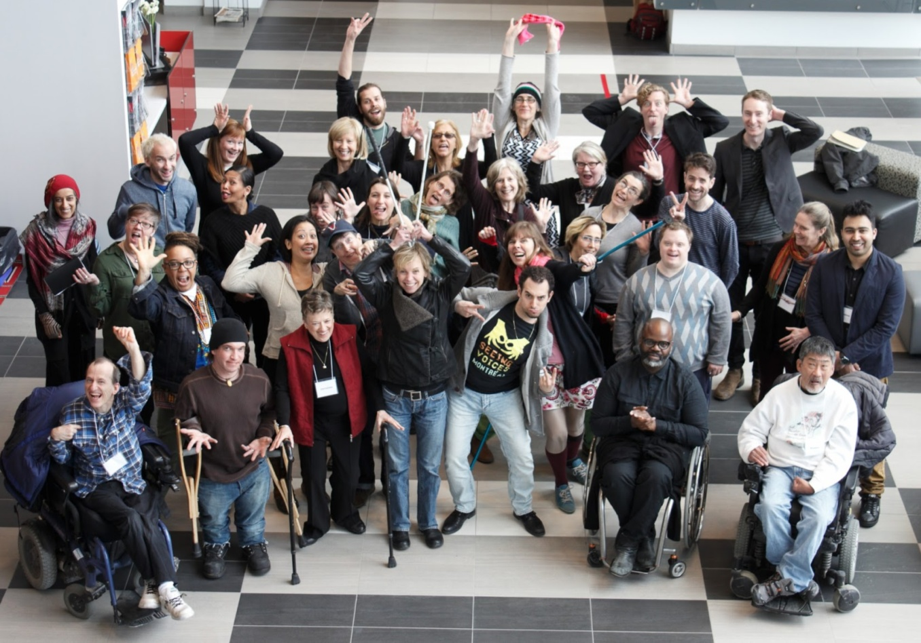
Image Description (ID): Photograph of the participants in the 2016 Summit, Inclusion: Deaf, disability and Mad Arts.

The second gathering, called The Study, is impacted by the findings of the first year and becomes the space and place to engage with the works and practices. The Republic of Inclusion is the third, public component that invites creative minds, producers and institutions from across the country, and around the world to share in the discoveries.

The Participants:
Syrus Marcus Ware and Sarah Garton Stanley co-curated The Summit 2016 in Stratford last April. This relationship continues as we move into The Study 2017 and The Republic of Inclusion. They will be joined by curatorial associate Jesse Stong, NAC producer Andy Lunney, and Producing Coordinator Clayton Baraniuk. The core company of 12 practicing artists and upwards of 30 specialists, academics and support personnel will spend 10 intensive days in Ottawa before opening up their findings to an audience for The Republic of Inclusion.

The Study - June 19-26, 2017
Canada Council for the Arts - 150 Elgin Street

Twelve esteemed and emerging Deaf, disabled and Mad artists will gather in Ottawa with plays, practices and various approaches to creation. Throughout the Study, they will be joined by upwards of 30 specialists (artists and thinkers with lived experience and practice). Together they will read, perform, interrogate and engage with portions of the Compendium of Work that exists within Deaf, disability and Mad arts in Canada.

The Republic of Inclusion is a culminating and public component that invites creative minds, producers and institutional key players from across the country, and around the world, to share in the discoveries. As with its name, The Republic of Inclusion is intended for all!

Partners in The Study & The Republic of Inclusion:
Image Description: Logos for National Arts Centre, Canada Council for the Arts, British Council, R. Howard Webster Foundation, British Columbia Arts Council, Ontario Arts Council, Stratford Festival, Tangled Arts + Disability, Canada Scene, The University of British Columbia Department of Theatre and Film, SSHRC, University of Guelph, Playwrights’ Workshop Montreal, Playwrights’ Theatre Centre, Theatre Alberta, Friends of English Theatre, NAC English Theatre

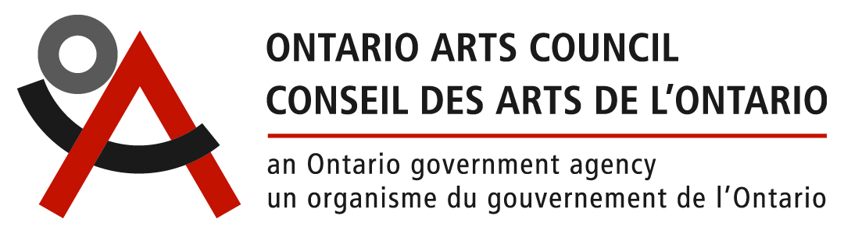

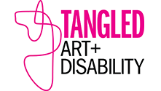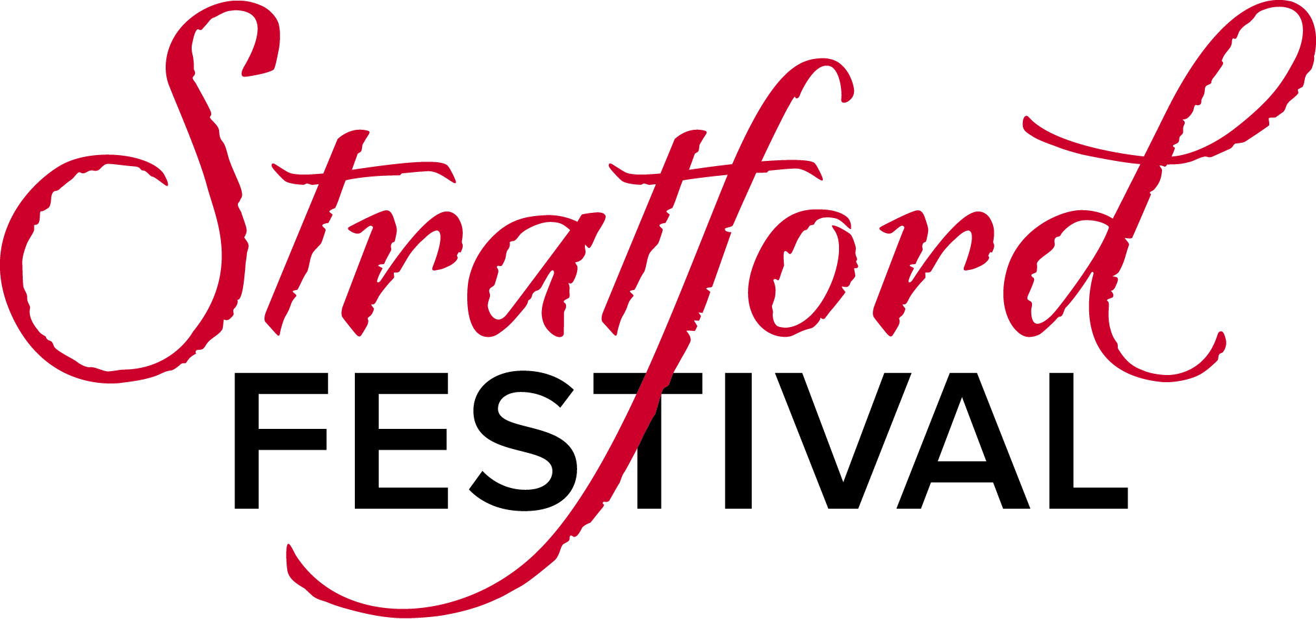

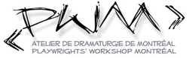

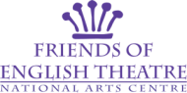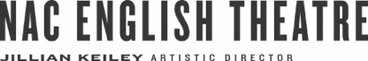

Biographies

Sarah Garton Stanley, Co-Curator
Originally, from Montreal, Sarah now lives in Kingston and works from Ottawa. She is the Associate Artistic Director, English Theatre and Interim Facilitator, Indigenous Theatre at Canada's National Arts Centre, creative catalyst for the SpiderWebShow, and a former Artistic Director of Buddies in Bad Times Theatre. During her career, Sarah has directed and dramaturged across Canada as well as overseas. Curator for The Collaborations and The Cycle(s) at the NAC, she also most recently directed Kill Me Now (Royal Manitoba Theatre Centre/NAC), Bunny (Stratford Festival), and Helen Lawrence (CanStage, Brooklyn Academy of Music, Munich Kammerspiele and elsewhere). She trained at École Jacques Lecoq, Vancouver Film School and received her BA and MA from Queens University. In 2016 Sarah received the Literary Managers and Dramaturgs of the Americas Elliot Hayes Award for dramaturgy.

Syrus Marcus Ware, Co-Curator
Syrus Marcus Ware is a Vanier Scholar, a visual artist, community activist, researcher, youth-advocate and educator. For 12 years, he was the Coordinator of the Art Gallery of Ontario Youth Program. Syrus is currently a facilitator/designer for the Cultural Leaders Lab (Toronto Arts Council & The Banff Centre). He is the inaugural artist-in-residence for Daniels Spectrum. Syrus works within the mediums of painting, installation and performance to challenge systemic oppression. His work has been exhibited at galleries across Canada. He is part of the PDA (Performance Disability Art) Collective and co-programmed Crip Your World: An Intergalactic Queer/POC Sick and Disabled Extravaganza (Mayworks, 2014). Syrus is part of the Black Triangle Arts Collective (BTAC), add a core member of Black Lives Matter Toronto. Syrus holds degrees in Art History, Visual Studies and a Masters in Sociology and Equity Studies, University of Toronto. Syrus is a PhD candidate in the Faculty of Environmental Studies at York University.

Jesse Stong, Associate Curator
Jesse Stong is a graduate of the National Theatre School of Canada (Playwriting, 2013). In 2016, he received the Young Arts Entrepreneur Award from the Michaëlle Jean Foundation for his innovative writing, puppetry, and performance workshops. His play for young audiences about online bullying, Shared Account, had a record-breaking school tour in 2015 with Geordie Productions (Montreal), and his new play for young audiences Water Weight is currently touring across Quebec and the East Coast. He is director of the Young Creators Unit for Playwrights’ Workshop Montreal, and proudly a board member of Les Muses - centre for dance and theatre training for people with intellectual differences.

Tangled Art + Disability
Tangled Art + Disability is boldly redefining how the world experiences art and those who create it. Tangled is a not for profit art + disability organization dedicated to connecting professional and emerging artists, the arts community and a diverse public through creative passion and artistic excellence. Tangled’s mandate is to support Deaf, Mad and disability-identified artists, to cultivate Deaf, Mad and disability arts in Canada, and to enhance access to the arts for artists and audiences of all abilities.
The Republic of Inclusion - June 27 - 29, 2017
Shenkman Arts Centre Richcraft Theatre - 245 Centrum Boulevard

Taking place from June 27 - 29 at the Shenkman Centre in Ottawa, The Republic of Inclusion will be an artistic experience inspired by the explorations of The Study and will feature a core company of leading and emerging artists and creators from the Deaf, disability and Mad arts community. The goals of this event include fostering greater knowledge and understanding of inclusion in an artistic context, and inspiring collaboration, partnership and programming that truly reflects Canadian diversity.

The Republic of Inclusion is for everyone. Dive into the immersive, accessible and inclusive world of Deaf, disability and Mad arts. Performance bursts, curated conversations, fine food and drink, djs and dance, live music and visual art await you! Featuring leading artists and creators from around the country and beyond, The Republic of Inclusion promises to reveal the scope of existing works, and practice in Canada.

Schedule Overview, Subject to change.

June 27, 2017 - 5:00pm - 9:00pm
- 5:00pm – 7:00pm Welcome Feast hosted by Canada Scene Festival
- 7:00pm - 9:00pm Inclusion Lounge Talk & Tunes

June 28, 2017 – 10:00am – 2:00pm
- 10:00am - 12:30pm - Morning Presentations & Activities
- 12:30pm – 2:00pm Lunch
- 2:00pm – 4:30pm Afternoon Presentations & Activities
- 5:00pm – 7:00pm Evening Meal hosted by British Council Canada
- 7:00pm – 9:00pm Inclusion Lounge Talk & Tunes

June 29, 2017 - 10:00am - 1:30pm
- 10:00am – 12:00pm Co-designing Work
- 12:00pm – 1:30pm Closing Lunch sponsored by the Canada Council for the Arts, with an information session lead by Alan Shain, Disability Arts Officer.

Some events will be Live Streamed online. Visit nac-cna.ca/inclusion in June for details.

Meals & Refreshments
Meals will be provided on June 27 (dinner), June 28 (lunch and dinner), and June 29 (lunch). Refreshments will be provided and available throughout the events at the Republic of Inclusion. Dietary restrictions and allergies will be accommodated. Should you prefer to provide your own meals, please let us know on the Registration Form.

Breakfast will not be provided on any of the days, but is available to purchase nearby or at the hotel.

Access at The Republic of Inclusion

Image Description (ID): Icons for Signed Interpretation, Audio Description, Listening Assist Devices, Captioning, Relaxed Environment, Wheelchair Accessible, Relaxed Spaces, Scent Free, Personal Support Workers, Service Animals, LiveStream

All events at the Republic of Inclusion will be in English only. Simultaneous translation into French or other spoken languages will not be provided.

Interpretation services in ASL, Captioning and Audio Description will be provided at all ROI events. Some services may be limited during meals. Listening assist services may be available, and speaking will be amplified. If you require alternate services, please let us know about your needs in your Registration Form. We will endeavor to provide access to support your full participation.

This event has been conceived of as a relaxed environment. Everyone is encouraged to stay for the entire presentation. Individuals may come and go, make noise and movement, use their technologies to assist with participation, and participate according to their abilities or their needs.

All spaces are accessible by wheels. There are two accessible elevators. There are accessible washrooms on both levels. Accessible parking is located near the entrance doors from the parking lot.

Designated relaxed spaces for privacy and rest are available if needed.

The Republic of Inclusion is scent-free and fragrance-free. Arrive without perfumes, colognes, or products with chemical fragrances such as deodorants, hair products or oils.

Support workers, attendants and guide or service animals are all welcome.

Some events will be Live Streamed online. Visit nac-cna.ca/inclusion in June for details.

Assistance finding therapeutic, medical or personal support services can be provided.

Please let us know if you require any medical or support services during your participation on your Registration Form.

The Shenkman Arts Centre Richcraft Theatre

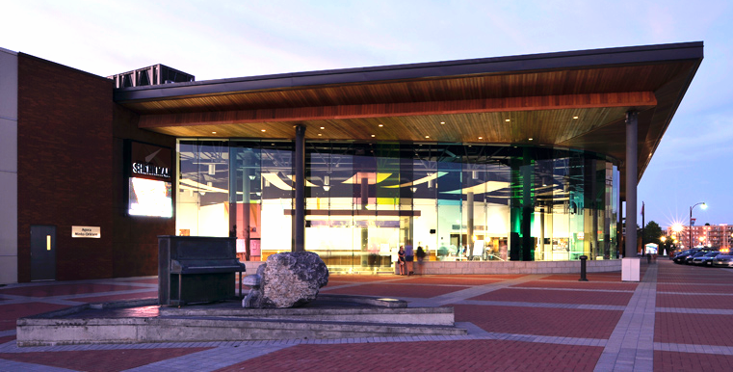
ID: The plaza and front entrance of The Shenkman Arts Centre

The Shenkman Arts Centre is located in Orleans, a 20 minute commute from downtown Ottawa. The facility opened in 2009, is LEED (Leadership in Energy and Environmental Design) Certified, and offers a high caliber of access to all exhibition, lobby and performance spaces.

The Republic of Inclusion will take place in the Richcraft Theatre, a flexible Studio located on the lower level of the centre. Other spaces for our use include music and dance studios on the upper level, and the lower lobby.

All spaces are accessible by wheels. There are two accessible elevator. There are accessible washrooms on both levels. Accessible parking is located near the entrance doors from the parking lot. Parking is free.

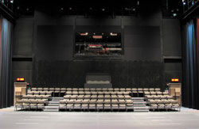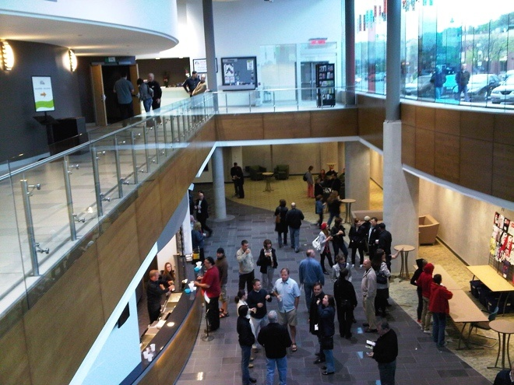
ID: The Studio floor and temporary risers of the Richcraft Theatre, and the upper and lower lobby areas of the Shenkman Arts Centre.
Accommodations at The Republic Of Inclusion

There are a variety of accessibility options available at our host hotels, from grab bars to roll in showers to pet-friendly rooms. To best allocate rooms, please indicate your accommodation requirements in your Registration Form and we will assign a room based on your information. We will do our best to accommodate all of your requests. Rates for all host hotels are between $125-$150 per night.

Holiday Inn Express & Suites – Ottawa East Orléans
The Holiday Inn Express is located across the parking lot from Shenkman Arts Centre on the north side of the building and has semi-accessible rooms. hieottawaorleans.com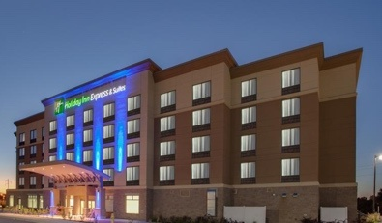 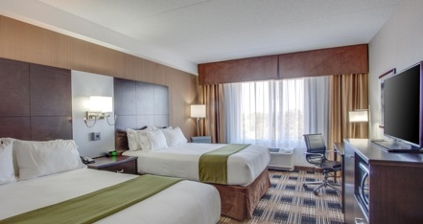 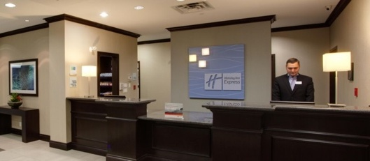
ID: The exterior of the hotel, a hotel room with two beds and the reception counter.

Quality Inn Orléans
The Quality Inn Orléans is located a 15 minute walk from Shenkman Arts Centre and has some fully accessible rooms with roll in showers. Qualityinnorleans.com
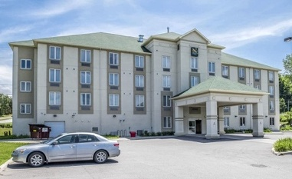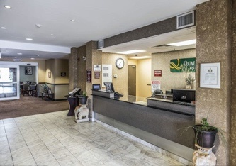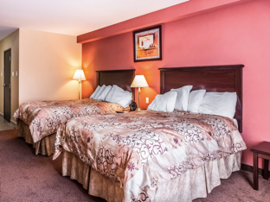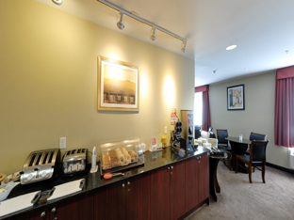
ID: The exterior of the hotel, the reception desk, a double room and the breakfast room.

Extended Stay Canada Downtown Ottawa
The Extended Stay is located in downtown Ottawa, and has semi-accessible rooms. The suites have kitchens, living room with a pull out couch, and a bedroom with one or two beds.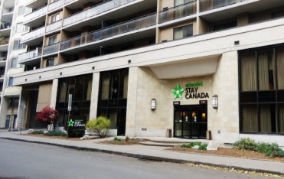 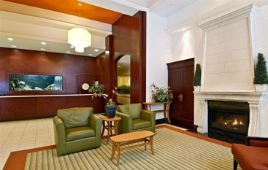 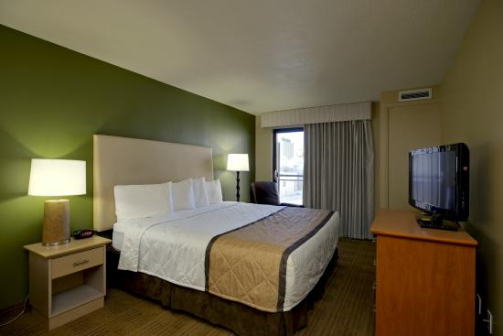 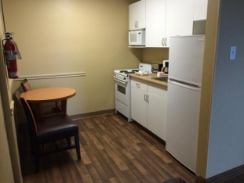
ID: The exterior of the hotel, the reception desk and lobby, a single bedroom, a kitchen with fridge, stove and microwave.

Transportation: Accessible shuttle service between the Quality Inn and the Shenkman Arts Centre will be available at the beginning and end of each day. Hotels in Downtown Ottawa may have access to a shuttle in the morning and the evening. Accessible taxi services and Uber rides are both available to return you to the hotels outside of shuttle times.

Accommodation registration deadline is May 19, 2017. After deadline, subject to availability.
Getting to Ottawa
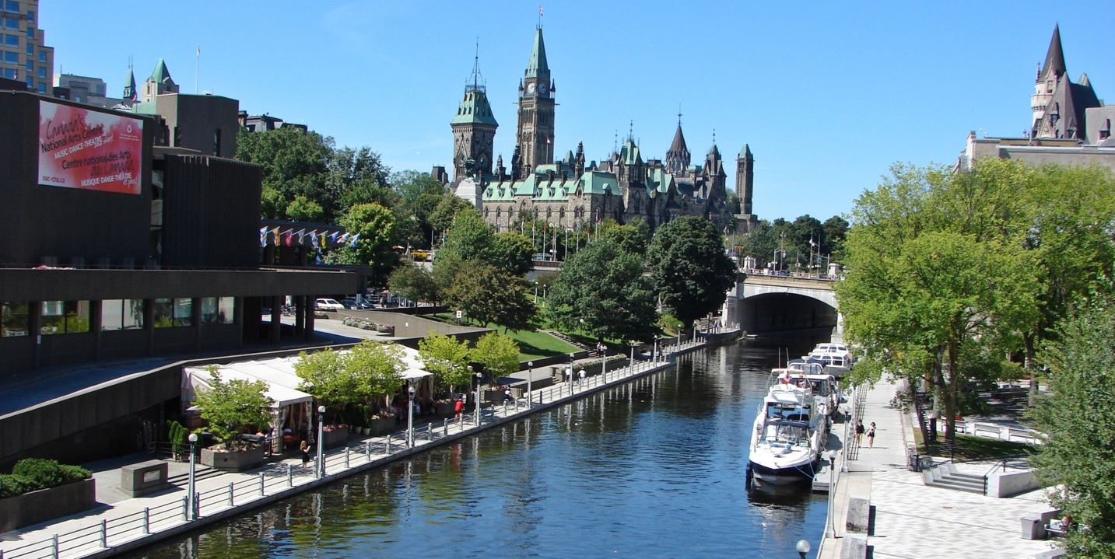
ID: The Rideau Canal, National Arts Centre and Parliament Hill in downtown Ottawa.

The Government of Canada has a website with details on accessible travel to, from and within various cities across Canada including Ottawa. Visit http://www.accesstotravel.gc.ca for some information and options.

Ottawa International Airport:
Ottawa International Airport is serviced by all major national and international airlines, including Air Canada, Porter Air, First Air and West Jet.

Airline Accessibility: Passengers travelling with wheelchairs or scooters must contact the Airline they are flying with before departure and provide information the weight and size of the wheelchair or scooter, and may be asked to provide information on the battery (for motorized scooters).

Passengers who require support within the terminal, getting on or off the plane, or with luggage are required to contact the Airline they are traveling on prior to arriving at the airport. The airline will provide necessary supports.

Companion Tickets: To access Companion tickets or discounts, the passenger with a disability must prepare an airline-specific form, completed by a medical professional (Doctor) and have it approved by the airline in advance. Contact the airline you are flying with about their individual policies before booking, as they vary.

VIA Rail:
Ottawa Station is serviced by VIA Rail along the Quebec City- Windsor corridor, connecting with departures from Toronto and Montreal. Tuesday is the “discount” ticket sale day online, each week.

Mobility: Each train offers a single tie-down position for a wheelchair or scooter, however some weight restrictions apply at certain stations (Montreal, Kingston among them). Wheelchair or scooter stowage options are available for those able to transfer to a regular train seat.

Assistance: VIA rail staff can assist with orientation at the Station, baggage, pre-boarding, onboard services and schedule changes. Passengers must request assistance from VIA personnel when they arrive at the station.

Companion Tickets: In certain circumstances, with specific documentation, a companion ticket for passengers accompanying people with disabilities may be provided. The passenger with a disability must provide a credentials indicating the need to travel with a companion, or have a valid card from a recognized institution or association for persons with disabilities. More information: http://www.viarail.ca/en/travel-info/special-needs/accessibility

Greyhound (Coach Bus):
Greyhound services Ottawa from Toronto and Montreal (and connects to much of Canada).

Accessibility: Greyhound bus service can provide storage for wheelchairs and scooters in the cargo holds of their coach busses. Access to the bus itself requires stairs. Companions or Personal Support workers may receive complimentary tickets, or may qualify for discounted rates by contacting Greyhound by phone at 1-877-463-6446.

Accessible Transportation Services - Ottawa:

OC Transpo (Public Transit): The majority of routes are serviced by low-floor, accessible buses that accommodate wheelchairs. More info: 613-741-4390

Para Transpo: There is a dedicated Para Transpo stop at the Airport and the VIA Rail train station. Passengers must make a reservation for this service. Info: 613-244-4636 / Reservations: 613-244-7272

Accessible Taxi Services: Ottawa has 180 wheelchair accessible cabs. Call Coventry Connections dispatch and request an accessible taxi: 613-523-1234

Accessible Car Rentals In Ottawa:
A limited number of accessible vehicles that can accommodate wheelchairs and are fitted with hand controls are available for rent. Customers are asked to make arrangements at least 48 hours in advance with the following car rental companies:

- Avis: (613) 739-3334
- Budget: (613) 521-4844
- Enterprise: (613) 248-0005
- Hertz: (613) 521-3332
- National: (613) 737-7023
- Wheelchair in Motion: 1-888-776-1102

Funding Sources to Support Attendance

There are a number of funding possibilities that may support your attendance at The Republic of Inclusion. If you are considering applying for funding, we recommend contacting the agency directly to ensure eligibility. If you require any support materials for your application, please let us know at least 5 business days prior to the deadline, and we will be happy to help if we can.

Region | Grant | Funder | Deadline | Amount | Office/Contact | Website
National | Arts Across Canada | Canada Council for the Arts | Anytime prior to departure | Up to $30,000 | Nancy Guertin  1-800 263-5588 ext 5484 | canadacouncil.ca
National | Application and Final Report Support | Canada Council for the Arts | 4 weeks prior to applying | Fixed Rates for accessibility supports | Equity Office  1-800-263-5588 ext 5060 | canadacouncil.ca
AB | CIP Travel Grant | Edmonton Arts Council | June 1st | Up to $750 | Steve Williams, Program Officer  (780) 424-2787 | www.edmontonarts.ca
AB | Artist Opportunity Grants | Calgary Arts Council | May 1st | Up to $2500 | Calgary Arts Development Office 403.264.5330 | calgaryartsdevelopment.com
MB | Professional Development | Winnipeg Arts Council | 6 weeks prior | Up to $1000 | Dominic Lloyd, Programs & Arts Development  (204) 943-7668 | winnipegarts.ca/
MB | Travel/ Professional Development Grant | Manitoba Arts Council | Ongoing | Up to $1200 | Tracey Longbottom - Consultant  204-9454-2237 | artscouncil.mb.ca/
NB | Professional Development | Arts New Brunswick | May 1st | Up to $1000 | Joss Richer Program Officer 506.444.5633 | www.artsnb.ca
NL | Professional Artists' Travel Fund | Newfoundland and Labrador Arts Council | Ongoing | Up to $1000 | Katrina Rice, Program Officer  709-726-2212 ext. 204  krice@nlac.ca | www.nlac.ca/grants
QC | Travel Grants | Conseil des arts et des lettres du Québec | 6 weeks prior | Up to $750 | 418 643-1707 or, 1 800 608-3350 | www.calq.gouv.qc.ca
YK | Cultural Industry Training Fund | Yukon Government/ Yukon Arts Centre | May 1st | Not Listed | Yukon Arts Centre  1-867-667-8476 | www.tc.gov.yk.ca

Registration Form

Due to limited capacity, all participants are required to register in advance. If you require support with your registration, please contact us at the coordinates at the bottom of this form.

Complete this form online at http://nac-cna.ca/republic or
Email completed registration forms by email to clayton.baraniuk@nac-cna.ca or
Mail complete registration form to: Clayton Baraniuk - English Theatre
National Arts Centre, 1 Elgin St, PO Box 1534 STN B, Ottawa, ON, K1P 5W1

Name:___________________________________________________________________

Street Address:____________________________________________________________

City:______________________________ Province/ State:__________________________

Country:________________________ Postal Code/ Zip Code:______________________

Phone Number:_____________________________________

Email Address:______________________________________

I am a Personal Support Worker for ____________________________________________

I preferred to be contacted by:
- Phone
- Email
- Skype/Glide with Signed Interpretation
- Through a Personal Support Worker or Caregiver

Personal Support Worker or Caregiver Name:____________________________________

Phone number:____________________________________

Email:___________________________________________

Please tell us how you participate:

To get around, I use: (Check any that apply)
- Feet
- A Wheelchair or Scooter
- Crutches
- Other: _______________________________________
Page 1 of 4
To participate, I require: (Check any that apply)
- General Admittance to the Event
- ASL Interpretation
- Audio Description
- Captioning
- A Listening Assist Device
- A Personal Support Worker
- A Support Animal
- Medical Equipment
- A Private Space available during the events
- Clear, detailed information in advance
- The ability to make noise or movement
- Other
(please describe):__________________________________________________________
Note: Please let us know if you use LSQ or English Sign or other services not listed.

I have: (Check any that apply)
- No allergies, sensitivities or dietary restrictions.
- Food Sensitivities
- Allergies
- Celiac Disease
- Dietary Restrictions
- Scent or Chemical Sensitivities
- Light Sensitivities
- Sound Sensitivities
- Temperature Sensitivities
- Sensitivity to touch (prefer limited physical contact)
- Anxiety
- Other:
(please describe):__________________________________________________________

Please list/describe your Dietary requirements or restrictions (ie – gluten free, vegan, vegetarian, specific food-related allergies, low-sodium or sugar needs, etc).

Please list/describe any allergies or sensitivities we need to be aware of (airborne, chemical, scent, fabric, textiles or anything else).

_________________________________________________________________________
Page 2 of 4
For accommodations (hotel rooms) I would like:
(Check any that apply)
- I do not require accommodations.
- A single room
- A room to share (I have a roommate)
- A room to share (I don’t have a roommate)
- Grab Bars in the room or bathroom
- Access to a Roll In Shower
- Elevator Access
- A Pet Friendly Room
- Access to refrigeration
- Private Accommodations (whole place)
- Private Accommodations (a room in a house)
- Parking
- Other:
(please describe):__________________________________________________________

General Information:
(Check any that apply)
- I will be driving into Ottawa, and am open to ride-sharing
- I am looking to find a ride-share if possible
- I live in Ottawa and could put someone up at my place.
- I have a vehicle and could offer rides to the events.
- I will have a Personal Support Worker with me at the events.
- I will provide my own food at all events.

Registration Fee: $50.00

Registration fees are non-refundable, and are spent providing food and refreshments at all events, as well as providing access supports for all participants. If your PSW would like to participate in shared meals, please have them complete a separate registration form.

- I am unable to afford the registration fee, but would still like to participate

I will pay by: (check one)
- Credit Card (Visa, Master Card, Amex)
- Cheque
- E-Transfer
- Cash

Signed: ______________________________ Date:___________________________
Page 3 of 4

Credit Card Payments:

Card Type: _______________________________________________________________

Name on Card: ____________________________________________________________

Card Number: _____________________________________________________________

Expiry Date:________________________ CVV Number (Number on the back):__________

Billing Address
- Same as the one provided above

Street Address:______________________________________________________

City:______________________________ Province/ State:____________________

Country:______________________ Postal Code/ Zip Code:__________________

Cheque Payments:
Please make cheques payable to National Arts Centre and mail to:

NAC English Theatre - Attention Clayton Baraniuk
1 Elgin Street, PO Box 1534 STN B
Ottawa, Ontario, K1P 5W1

Note: Please include the participant(s) name(s) on your cheque.

E-Transfer Payments:
Please send e-transfer to clayton.baraniuk@nac-cna.ca
For the security question, please use the name of your street, provided above.

Cash Payments:
Cash payments may be made in person at the National Arts Centre to Clayton Baraniuk (ext 386) or upon arrival.

Confirmation:
We will be in touch to confirm your completed registration within 5 business days of receiving it. For more information or to complete this registration form over the phone, please contact Clayton Baraniuk, Producing Coordinator, and suggest two or three dates and times to connect.

Clayton Baraniuk, Producing Coordinator, English Theatre, National Arts Centre
613-947-7000, extension 386 | clayton.baraniuk@nac-cna.ca
Page 4 of 4

